TABLE OF CONTENTS

1. Employment testing system using Psychometric instruments 1
1.1 What is Employment testing? 1
1.2 When do Employment tests make the most sense? 2
1.3 What are the Reasons for testing? 2
1.4 What are Psychometric Tests? 3
1.5 What Types of Psychometric Tests Exist? 3
1.6 Why do Private and Public Sector Employers Use Psychometric tests? 5
1.7 What are the Reasons for using Psychometric testing? 7
1.8 A Recommended psychometric system 9
1.9 Steps and Procedures in establishing an effective employee Psychometric testing program 9
1.10 International trends in the employment of Psychometric tests in Recruitment 13
1.11 Psychometric tests developing companies 17
1.12 Examples of Psychometric Test Questions 18
1.12.1 Ability Tests Examples (Verbal) 18
1.12.2 Ability Tests Examples (Numerical) 19
1.12.3 Abstract Test Examples 20
1.12.4 Personality Test Example 21
1.12.5 Example of Personality Test Individual Report 22

Employment testing system using Psychometric instruments

In further strengthening the previously mentioned recruitment processes, an employment Psychometric instrument (test) should be utilized.

What is Employment testing?
Employment testing is the practice of administering written, oral, or other tests, as a means of determining the suitability or desirability of a job applicant. From an assessment standpoint, a test is a standardized series of problems or questions that assess a person’s knowledge, skills, abilities, or other characteristics. In this document, when we refer to employment testing, we mean standardized tools used or applied as per need or fit in hiring, promotion, demotion, membership, referral, retention, and licensing and certification decisions.

When do Employment tests make the most sense?
Employees affect an organizations performance and profitability. Hiring or promoting people who are unsuitable costs time, money, and potential new business. Carefully developed and administered employment tests can provide organizations with a way to decide systematically and accurately which people have the ability to perform well on the job, will not turnover, won’t engage in counterproductive behaviors, or will be able to learn from training programs. Tests can also benefit individuals who are better matched to positions for which they are suited and in which they will wish to remain.

What are the Reasons for testing?
Some of the more commonly cited reasons for testing are:
Testing leads to savings in the decision-making process. Employment tests can be a cost effective way to pare down the applicant pool. Tests can make the decision process more efficient because less time is spent with individuals whose characteristics, skills, and abilities do not match what is needed. However, some tests do require more time up-front with individuals to determine who is and who isn’t qualified. In these cases, tests can still result in savings from not training and compensating individuals whose productivity would be low or who would not remain on the job.
The costs of making a wrong decision are high. For certain employment decisions, a wrong decision can be very costly in terms of training costs, errors made by a poor performer, costs of replacement, etc. For these types of decisions, investing in testing may be seen as a particularly worthwhile endeavor if testing reduces the number of wrong decisions.
The job requires attributes that are hard to develop or change. Tests are often used for assessing characteristics that cannot be developed through training but are acquired over long periods of time or even a lifetime (e.g., personality traits, in-depth knowledge of a profession).
Hard-to-get information can be obtained more easily and efficiently. One important advantage of using employment tests is that they can often provide information about an individual that is not easily obtained using other methods, or that would be much more costly to obtain by other means.
Individuals are treated consistently. Using standardized tools in employment decision-making ensures that the same information is gathered on each individual and used in a similar way in decisions. Employers often turn to testing because of the unfairness of less standardized processes, in which individuals are not all treated in a similar way and similar information is not gathered on all individuals. Subjective biases can easily creep into decisions if the process for making decisions is unstandardized.
There are a lot of applicants. Sometimes the sheer number of individuals to consider for an employment decision leads an employer to choose testing as the most efficient and fair means of making a decision in a timely manner.

What are Psychometric Tests?
Psychometric tests are standardized psychological measurements of knowledge, abilities, attitudes or personality traits. Psychometric tests have been extensively used in commercial, academic and educational settings for centuries and their popularity has continued to increase. Psychometric tests work by recording a candidate’s responses to a set of questions, designed to measure a specific psychological construct, such as cognitive ability or personality. These psychological constructs have been found to be related to real-world outcomes, such as job performance, trainability and competence. In an employee selection setting, psychometric tests provide the ultimate insight into a candidates potential, providing a meaningful and highly valid prediction of that candidates knowledge, skills, abilities and other characteristics of good job performance. Psychometric tests may be purchased by organizations from psychometric test publishers off-the-shelf, or alternatively bespoke psychometric tests may be designed specifically for an organization.
Traditionally, psychometric tests have been administered in paper/pencil format, but modern psychometric tests now use the internet for delivery. This means that hundreds, or even thousands, of candidates can be tested from the click of a button, and their data can be compiled and reported automatically. Today, the vast majority of psychometric tests are conducted online, leading to massive growth in the psychometric testing industry. Candidates from all job levels, from entry level staff to chief executives, can be assessed by these tests, as psychometric tests are highly effective predictors of job performance in any role or selection process. Additionally, employing organizations are increasingly using bespoke psychometric tests, assessments designed specifically for their organization. This allows organizations to tailor assessments to the role, guaranteeing congruency between the role and its assessments.

What Types of Psychometric Tests Exist?
The word psychometric basically refers to the measurement of the mind, or soul. It derives from the Greek words “psycho” meaning soul, or mind and “metric” which means measurement.
Generally speaking, psychometric tests for selection and assessment aim in assessing the cognitive abilities, and the personalities of the candidates.
The most common types of psychometric tests can be grouped into 3 categories, i.e. the Aptitude or Ability tests (Verbal and Numerical reasoning tests), the Abstract reasoning or spatial tests, and the Personality and Occupational Behavior tests/questionnaires.

a) The APTITUDE or ABILITY TESTS (verbal/numerical reasoning)
These aim to measure cognitive competence and intellectual capabilities as well as logical and analytical reasoning abilities. They aim to assess abilities to use specific skills, and to predict subsequent job performance. The most commonly used Aptitude/Ability tests assess verbal and numerical logical reasoning skills
Verbal reasoning - Although these tests may appear in different formats, verbal reasoning typically involves reading a passage of text and then selecting the most appropriate of perhaps four or five answers, or sometimes True or False for an answer, or fill in blank spaces in a sentence with a given choice of words
Numerical reasoning - Although these tests also appear in different formats, you may typically be asked multiple choice questions relating to information provided in the form of arithmetic questions, or statistical charts, or you may be required to calculate the answers to various problems.

b) The ABSTRACT REASONING or SPATIAL TEST
These tests, frequently called spatial (related to space), are designed to assess and measure general intelligence, along with analytical and conceptual thinking and problem solving. They use symbols and sequences
Abstract Reasoning measure’s a person's ability to comprehend and work with unfamiliar information to find solutions to problems, with the aim of discovering how well the person can think analytically and conceptually. The test format involves looking at a sequence of symbols, and determining how to complete the sequence. These tests are usually based on diagrams and measure a person’s ability to identify the underlying logic of a pattern and then determine the solution. Additionally these tests measure the person’s ability to manipulate shapes in two dimensions or to visualize three-dimensional objects presented as two-dimensional pictures

c) The PERSONALITY and OCCUPATIONAL BEHAVIOR TESTS
The These tests explore a) the way in which people do things, and how people behave in certain circumstances, (i.e. empathy, assertiveness, directiveness, leadership, customer orientation, flexibility, T&C), and b) peoples’ preferences and attitudes.
In recruitment they are often used to see if a person would suit a particular work environment and can be used to assess aspects of one’s individual behavior, attitudes and opinions, as well as the person’s motivation, interests and values. The candidate’s results may then be compared to the characteristics considered essential for the job on offer. In recent years they are mostly computer- based, questionnaires, where a profile is drawn from one’s responses to a number of questions or statements, focusing on a variety of personality factors.
For all types of personality questionnaires there are no right and wrong answers.
Other psychometric tests, such as situational judgment tests draw aspects from both cognitive ability tests and personality questionnaires. As a result, many psychologists consider these exercises to be an intermediate between cognitive ability tests and personality questionnaires.
Additionally, the market offers various other situational tests (tests that measure specific dimensions/needs for a particular job profile) such as the Integrity Tests. These are written tests that predict whether an applicant will engage in theft or other counterproductive activities. They have proved to be effective in helping to avoid costly hiring mistakes, especially in jobs where theft or shrinkage has traditionally been a problem. Integrity tests can be a less expensive alternative to background investigations, but they are not as reliable at detecting past criminal behavior.
Another situational test is the Physical Abilities Test. Such a test could involve having candidates complete physical exercises to assess talents and capabilities such as strength, endurance, dexterity, and vision. They tend to be used only for very physically demanding jobs such as firefighting.
Due to the range of psychometric tests on the market, it is always advisable to discuss psychometric testing with an expert before deciding on the use of the appropriate combination of psychometric tests in the particular organization or workplace.

Why do Private and Public Sector Employers Use Psychometric tests?
Employers utilize psychometric testing for a multitude of reasons, which are summarized below:
1. Job performance: Cognitive ability tests are the most powerful and valid predictors of job performance available today and cognitive ability tests are over 14 times more predictive of job performance than the average selection interview (Hunter & Hunter, 1984). Well-researched psychometric tests are the most powerful selection tools available today, outperforming all other selection tools enormously. What's more, psychometric test results also show statistically significant relationships with other workplace relevant variables, such as training success, job knowledge, organizational citizenship behaviors and task performance.
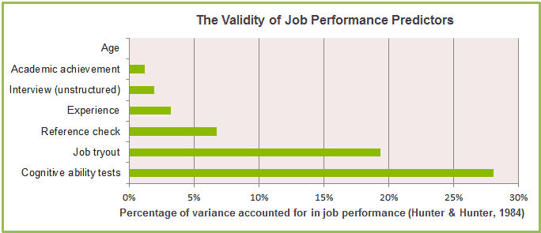

2. Organizational performance: The use of psychometric tests in the workplace has been found to lead to the following workplace outcomes: Increased organizational performance, increased employee retention, reduced cost per hire, decreased employee turnover, decreased absenteeism and higher levels of employee engagement/motivation. Selecting top performing candidates and ensuring a high quality workforce is imperative for any organization and psychometric testing is the ideal mechanism for ensuring this.
3. Convenience: Online psychometric tests can be sent to candidates at the click of a button, individually or by the thousand. As a result, psychometric testing is infinitely less time intensive than other selection process, such as interviews and assessment centers. Moreover, once a candidate completes their assessment, reports are automatically generated and available for viewing within seconds, requiring little input from staff. This makes psychometric testing ideal for pre-employment screening, high volume recruitment or busy human resources departments.
4. Return on investment: Psychometric testing provides a powerful way of ensuring the best candidates are selected by assessing their cognitive ability and preferred behavioral styles. Consequently, the use of Psychometric testing improves the efficiency of the recruitment process by identifying the most suitable candidates, early on in the recruitment process, thereby reducing the time and money spent on unsuitable candidates.
5. Objectivity: Selecting employees using well researched psychometric tests increases the fairness and objectivity of an organization’s selection process. This means that employees can be selected on merit using fair and standardized tests, rather than subjective selection through unreliable methods. Unstructured interviews are classic examples of subjective and inefficient selection tools, which may screen out high performing candidates unnecessarily. Fair, standardized and selection tests are a great way to increase the fairness and objectivity of your selection process, helping organizations avoid legal disputes over unfair selection decisions.

What are the Reasons for using Psychometric testing?
Psychometric basically refers to the “metric”/measurement of the “psycho”/mind, or soul. Unlike facets such as education, skills, experience, appearance and punctuality, the behavioral traits and personality of a candidate can be much more difficult to assess during an interview.
Some employers choose to use psychometric testing during their recruitment process to help give a better overall evaluation of a candidate and hopefully secure the best fit for the role. As with many assessment instruments, there’s some debate over the value of psychometric testing, but those who use it overwhelmingly believe that it can give a more objective overview of a candidate’s character, strengths, weaknesses and working style. Typically, a psychometric test will be used as one component of a wider, integrated evaluation strategy.
For employers, psychometric testing could help to gauge the future performance of a candidate and hopefully improve employee retention by making successful hiring decisions.
How psychometric testing aids recruitment decisions
Psychometric testing can measure a number of attributes including intelligence, critical reasoning, motivation and personality profile. An interview process can be fairly subjective and although employers will normally assess skills and experience fairly accurately, much can still be left to gut instinct regarding aligned values.
A psychometric test aims to provide measurable, objective data that can give you a better all-round view of a candidate’s suitability. It could be argued that psychometric testing offers some ‘scientific’ credibility and objectivity to the process of recruiting. It perhaps provides a more fair and accurate way of assessing a candidate, as all applicants will be given the “same for all” standardized test.
Traditionally, these tests have taken the form of pen and paper, multiple choice questionnaires, but increasingly they’re moving into a digital realm. This means they can be quick and easy to integrate into any stage of the process.
Some organizations often favor psychometric testing as a way of screening (and subsequently eliminating) large amounts of candidates at the start of a recruitment drive. In this case, psychometric testing could help to drastically reduce the hiring manager’s workload, as it helps to swiftly identify a smaller pool of suitable applicants who have the potential to perform well in the later stages of interview.
What do they measure?
There are different types of tests, but generally they’ll be used to measure how people differ in their motivation, values, priorities and opinions with regard to different tasks and situations. In terms of personality, the tests can give an indication of the working style favored by a candidate and how they interact with both their environment and fellow workers.
The tests are helpful at analyzing the more ‘hidden’ traits of an individual. Formal education and past experience will not always provide a clear, up-to-date assessment of these personal skills. Aptitude tests, for example, could help to provide a better, more realistic and current view of a candidate’s abilities than a formal certificate of education.
Thus the applications of psychometrics are various and the benefits arising from their use can include the following:
- maximizing an organization’s performance by improving accuracy of selection;
- improving employee retention by better matching individuals to jobs;
- avoiding the financial and personal costs associated, on both sides, with poor recruitment decisions;
- optimizing the use of people’s capacities by helping focus development activity;
- achieving better career management by matching individual aspirations to their organization’s opportunities.

In the recent years many of the psychometric tests have been produced in various languages, to avoid the unfairness of those not been natural or proficient users of the English language

A Recommended psychometric system
A Recommended psychometric system for entry, lower and up to middle level positions for mass recruitment, would be a combination of an Ability (verbal and numerical) test along with an Abstract test that can give a good indication of the cognitive abilities (verbal, numerical and problem solving) of the candidates.
A combination of the above two instruments along with a Personality/Occupational Behavior test is mostly recommended for middle and upper level positions, as the Personality tests are more expensive and time consuming as they require a competency modelling and individual candidate reports, that compare and match the candidates personality with the roles’ defined behavioral competencies
Due to the range of psychometric tests on the market, it is always advisable to discuss psychometric testing with an expert before deciding on the use of the appropriate combination of psychometric tests in the particular organization or workplace.

Steps and Procedures in establishing an effective employee Psychometric testing program
Initially, an organization should discuss at the decision making levels (i.e. CSB, OMSAR, and the project’s Task Force) the need, the fit, and the benefits deriving from the use of a battery of Psychometric tests to their particular recruitment process.
Upon their decision to proceed with the utilization of such instruments, and the appointment of a “delegation”, certain steps should be taken in an effort to establish a valid, beneficial and sustainable implementation such system
- Communication of the delegated Task Force personnel with a number of companies, and invitation/arrangement for an initial meeting with specialists from certain chosen Assessment companies that specialize in Psychometric Testing
- During this initial “get to know” meeting, a thorough analysis and exhaustive discussion will take place in reference to recruitment needs of the appropriate department(s) of the Public Sector, and the tests offerings that could match and best serve these needs from the Assessment Company’s perspective. The Assessment Company might suggest at this point their most suitable instruments for the assessments.
- Certain procedural issues (i.e. numbers of assesses per day, time of tests, coding and passwords way of provision, location of testing, etc.) and technical needs for Testing implementation (i.e. internet connectivity, equipment and ICT systems needed, minimum operating PC systems, etc.) should be exhaustively discussed and the availability of them should be clearly defined.
- Following the previous discussions, the financial/business issues (i.e. costs per participant, costs of training for one or more certified assessor(s) from the Organization’s part, and any other fees or additional possible costs will be discussed
- Financial and procedural agreements will be drafted, agreed upon and signed among the Organization and the Assessment Company of choice. Test implementation timetables might be arranged, at this stage
- The Organization should decide and designate the personnel that should be send for training and accreditation in order to effectively use and administer the Assessment Company’s testing instruments
- The Assessment Company (in close cooperation with the Organization) will assign lists with codes and passwords for the tests’ candidates, and both parties will define the exact dates, times and numbers for tested applicants per day
- The Organization will publish to the candidates the lists with the names and the location, time and date that their exams will take place
- Actual tests take place under the instruction and the supervision of the previously certified assessors from the Organization’s part.
- The Assessment Company will provide tests results to appointed Organization’s personnel, according to the designated codes of the candidates
- The Organization’s appointed committee/personnel will decode the codes and match the names of candidates with their tests results, in a ranking order, and decide on the number (or percentage) of applicants “successful” rates, and the number of the one’s that will be considered “failed”
- The Organization will then publish the lists of successful candidates that are entitled to continue the testing process, and invite them for the continuation of their per Ministry specific final tests
- Final tests successful candidates list will be prepared and published.
- Final hiring procedures take place.

TYPICAL PSYCHOMETRIC TEST PROCEDURE FLOW DIAGRAM
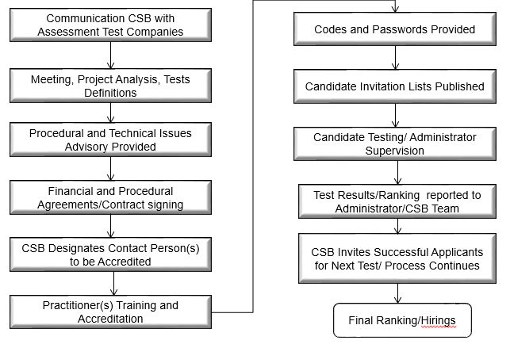

International trends in the employment of Psychometric tests in Recruitment
Psychometric tests have been used since the early part of the 20th century and were originally developed for use in educational psychology. These days, outside of education, you are most likely to encounter psychometric testing as part of the recruitment or selection process. Tests of this sort are devised by occupational psychologists and their aim is to provide employers with a reliable method of selecting the most suitable job applicants or candidates for promotion.
Psychometric testing in Recruitment (as well as in other phases of Human Resources Management such as in Talent Management, Career Pathing, Succession Planning, assessment Centers, Training and Development), has for long time been utilized in a significant number of companies in the Private sector.
Nowadays over 70 per cent of large Australian firms use psychometric testing as part of their recruitment process. They are used by employers to help assess a candidate’s suitability for a particular job and usually consist of an ability/aptitude test and a personality questionnaire.
Organizations such as information technology companies, financial institutions, management consultancies, the public service, police forces, fire services and the armed forces are particularly likely to use this sort of test to help screen candidates, although many other types of companies also use them.
Online testing is becoming increasingly common and used at earlier stages for initial screening, to help filter out unsuitable candidates and find those who will be asked to come in for an interview.
Psychometric testing is now used by over 80% of the Fortune 500 companies in the USA and by over 75% of the Times Top 100 companies in the UK. Information technology companies, financial institutions, management consultancies, local authorities, the civil service, police forces, fire services and the armed forces all make extensive use of use psychometric testing.
Indicatively some of them include:
ExxonMobil, Chevron, Ford Motor, KPMG, Hewlett Packard, Citi Group, Procter & Gamble, Microsoft, JP Morgan, Mc Donald’s, Bank of America, Barclay’s UBS, 3M, Publix Supermarkets, TullettPrebon, Capital One Financial, Raytheon, Union Pacific, Ernst &Young, EON, Exelon, Duke Energy, Royal Bank of Scotland (RBS), Grant Thornton, Australia Defence Force, Deloitte, Southern Company, Ambulance Victoria GAP, NextEra Energy, etc.
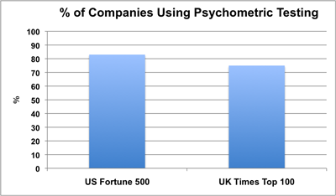

Following these trends, Many Governments and Publicly owned Corporations have introduced modern systems of their Human Resources Management tactics, including the use of Psychometric Tests in Recruitment.
Pioneers on these trends and developments are the Western World’s most developed countries, including the Governments of European, American, and Australian States
The Council of Europe works with TalentQ Assessment Company for volume recruitment, and employee development purposes
The European Personnel Selection Office (EPSO) is using psychometric tests extensively on their own intranet
Australian Public Service Commission uses extensively Psychometric Tests for public servants, and recently it has cooperated with DFP Company for this purpose.
DFP Assessment Company, is an approved supplier for New South Wales (NSW) State Government Agencies in Australia, under the SCM0007 Contingent Workforce Scheme for Temporary and Contract personnel under Categories A, B and C.
Belgium has acquired SELOR Assessments Company, to be its exclusive provider in administering Psychometric Tests for several Governmental agencies
In the Government of Ireland the recruitment is managed by the Public Appointment Service. Recruitment assessment processes are similar with those to Belgium’s testing, (job simulations and psychometric testing). A ranked list of successful candidates is generated, and offered employment as vacancies become available.
UK has developed the PSG, (Professional Skills for Government) competency framework, for all levels and all grades of public servants, and psychometric tests are employed to assess these competencies.
Similarly USA is employing psychometric testing in various Governmental agencies, such as the IRS (Internal Revenue Service), the armed forces, and the national security agencies.
Many Government majority owned corporations such as Banks, Energy, Transportation, or Telecommunications companies, have utilized various assessment techniques, (such as Case Studies, In Basket exercises, Behavioral Event Interviews and Psychometric Testing for recruitment, internal promotion or succession planning, and development purposes.
Examples include the Ministry of Culture, and the Agricultural Bank in Greece, the Nacionalna Stedionica Bank of Serbia, the DZI Bank of Bulgaria, the DP world of Dubai, the Central Bank (CBO) and the Electricity Company (EHC) of Oman.
Finally, many Governments in South America and Africa, (e.g. Mexico, Colombia, Nigeria, Nepal, Ghana), have started developing Job Descriptions and Competency models for their governmental Agencies and Ministries, and plan to start employing psychometric tests in recruitment in an effort to cut costs, and curb possible corruption.
On behalf of the Public Appointments Service (PAS) Research Advisory Panel, in page 27 of his report “E-recruitment practices and trends in Ireland”, (as shown in the graph below), Mr. Bryan Andrews its Chief Executive Officer presents a recent case of using Psychometric Testing and assessment centers in a Graduate Recruitment for the government, emphasizing the cost and the time benefits of employing such practices, by eliminating the vast majority of the 17000 applicants in a very short time!
To view the whole report, “e-Recruitment: Practices and trends in Ireland - Publicjobs.ie” please visit its electronic address in: https://www.publicjobs.ie/.../e_Recruitment_report.pd

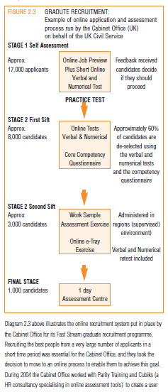

Psychometric tests developing companies

A variety of companies exist in the world, who are professional psychometric testers and who offer assessment and development for individuals, groups, and organizations. Some of them, among the best known ones, are:

- TalentQ/HayGroup
- Cubics
- Hogan Assessments
- Hogrefe
- Kenexa
- OPP
- Provisor
- Saville
- SHL /Team Focus
- Thomas International
- Psytech
- Hudson Assessments

Examples of Psychometric Test Questions
Following please find some examples of Psychometric Tests

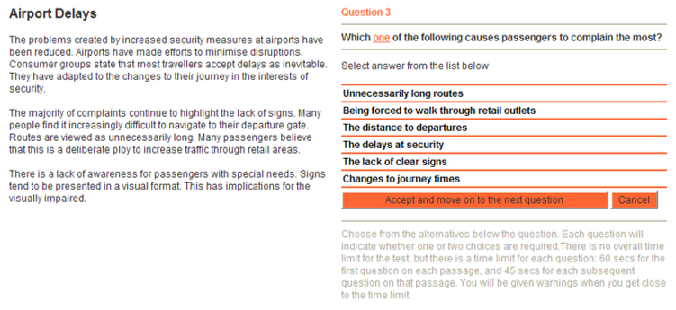
Ability Tests Examples (Verbal)
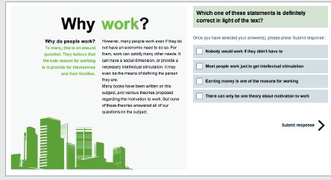

Ability Tests Examples (Numerical)
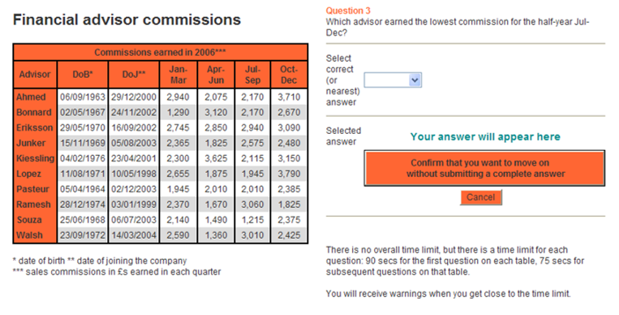
Includes 12 questions based on information presented in tables. The questions are designed to measure a candidate’s ability to analyze and draw inferences from numerical information and data.

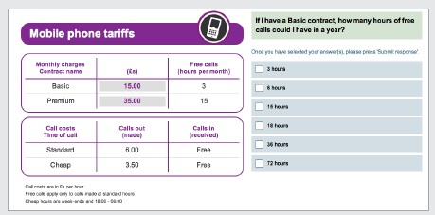

Abstract Test Examples
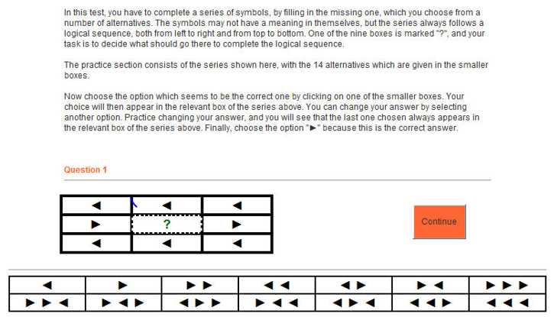
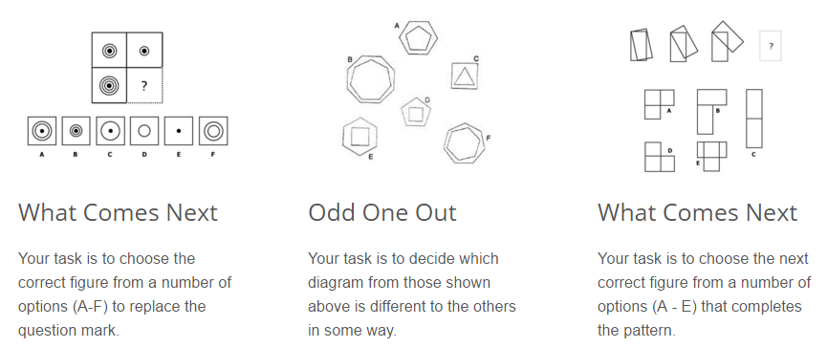
How does a typical Abstract Reasoning question look like?

Personality Test Example
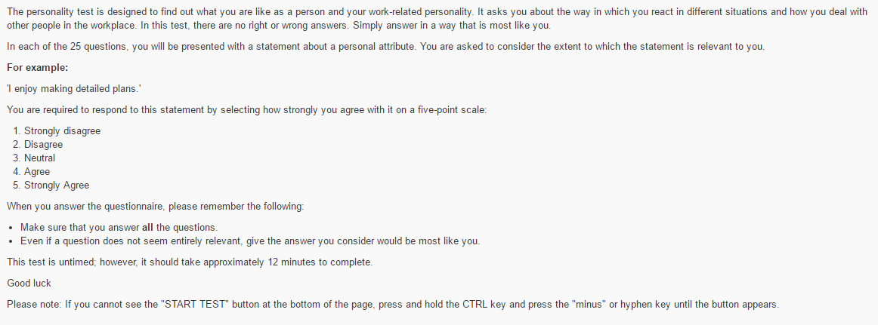
Note: To view the rest of the 25 questions of the test please refer to:
http://www.psychometricinstitute.com.au/

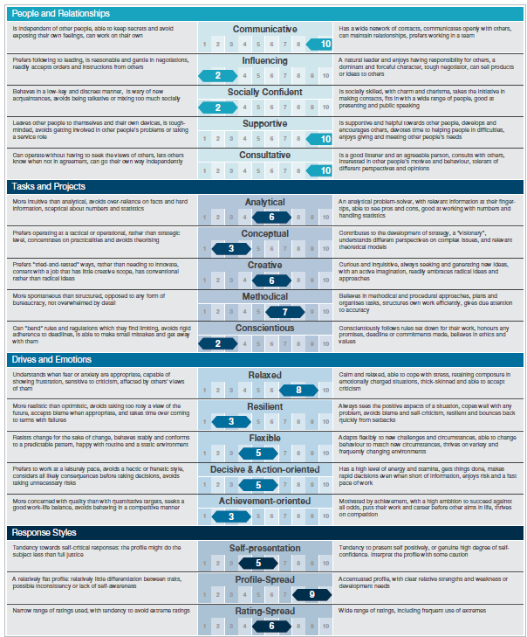
Example of Personality Test Individual Report

For more Psychometric Test examples, please refer to the following electronic addresses, or use your search engine to locate similar test examples

http://www.practiceaptitudetests.com/verbal-reasoning-tests/
http://www.iqtest.dk/main.swf
http://www.psychometricinstitute.com.au/
https://www.jobtestprep.co.uk/jobtestprep/testPlayer.aspx

